**Calculating Family Expenses Using Service Now**

**Team ID** : NM2025TMID16358

**Team members** : 4

**Team leader** : AARTHI. R

**Team member** : AISHWARYA.S

**Team member** : JEEVITHA. R

**Team members :** JANANI .S

**Problem statement** : The project aims to develop a comprehensive expense calculation system using Service Now. This system will enable users to track and manage family expenses efficiently. It will include features such as expense categorization, budget setting, real-time tracking, and reporting capabilities. Utilizing Service Now’s robust platform, the project will ensure seamless integration, user-friendly interface, and scalability to accommodate varying family sizes and financial complexities. The end goal is to empower users with the tools they need to make informed financial decisions and promote financial well-being within the family unit.

**Objective** : To develop a smart, scalable family expense tracking system using Service Now

**Skill** : Real-time Tracking and Budget Management

**Milestone 1 : Setting up Service Now Instance**

1. Register for a developer account on the Service Now Development site <https://developer.servicenow.com>.
2. After logging in, go to the “Personal Developer Instance” section.
3. Click on the “Request Instance” button to generate your personal Service Now instance.
4. Once the instance is ready, the system will automatically email you the details
5. Please, Log in to your Service Now instance using the credentials that have been provided
6. You will now proceed to the Service Now platform

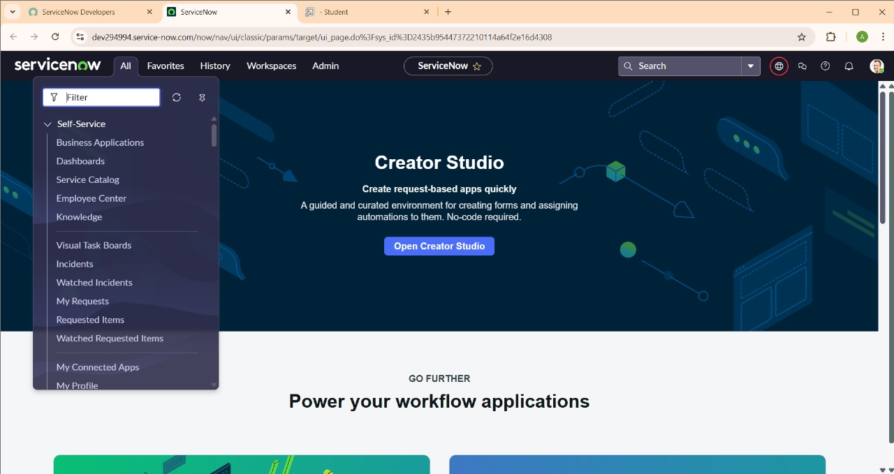

**Milestone 2 : Creation of New update set**

1. Go to All >> In the filter, search for Local Update set > click on New.

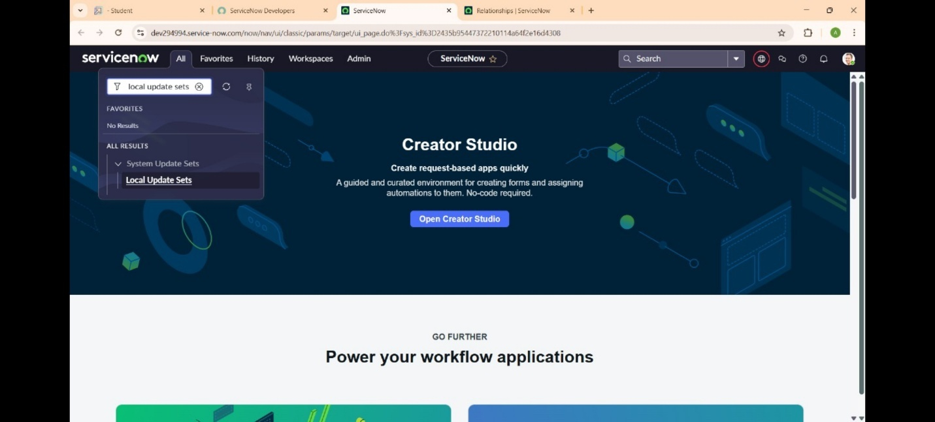

1. Please enter the details as specified :

* Name : Family Expenses

1. 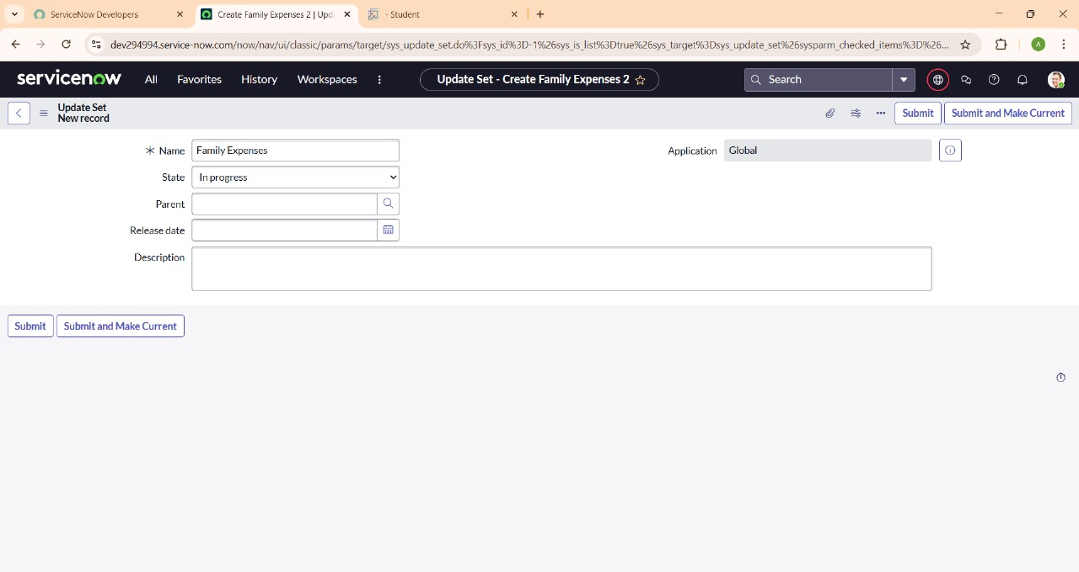Next, click submit, then make current.

**Milestone 3 : Creation of table**

1.Go to All >> In the filter, search for Local Update set > click on New.



2. Please enter the details as specified :

* Name : Family Expenses

1. ****Next, Click on submit and make current.

**Milestone 4 : Creation of table**

**Activity 1 : Family Expenses Table**

1. Go to All > In the filter search for Tables > click on New.
2. Please Enter the Details as specified :

* Label : Family Expenses
* Name : Auto-Populated
* New menu name : Family Expenditure

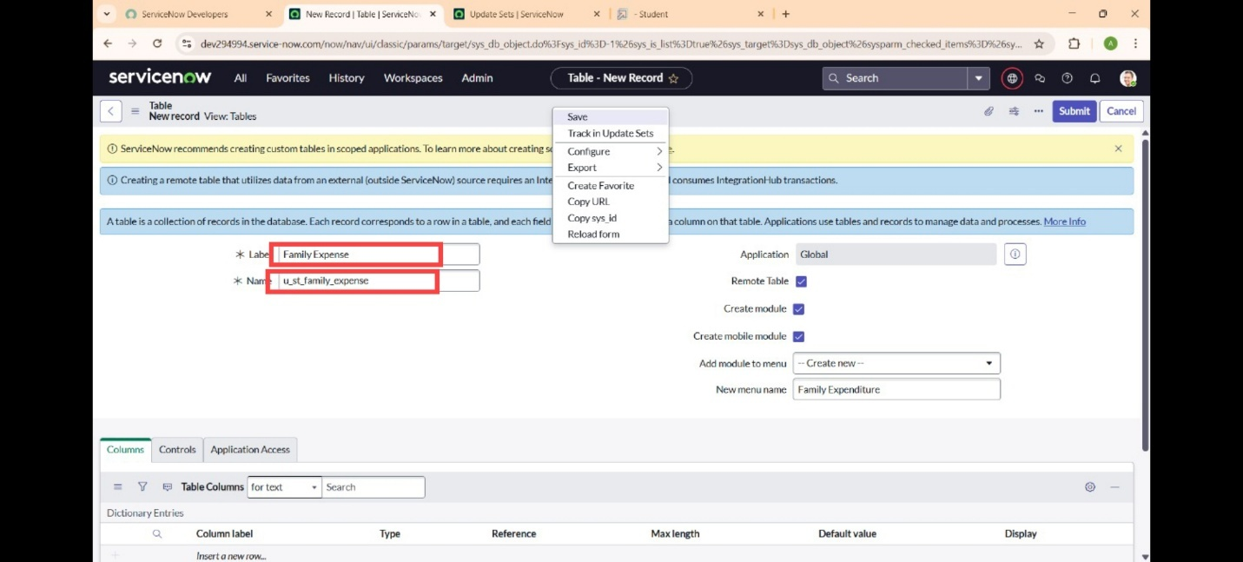

1. Move to the header, right click there >> click on Save.

**Activity 2 : Creation of Columns(Fields)**

1. Near Columns Double click near insert a new row.

Fill out the details as:

* Column label : Number
* Type : String

1. Double click on insert a new row again

Fill out the details as:

* Column label : Date
* Type : Date

1. Double click on insert a new row again

Fill out the details as:

* Column label : Amount
* Type : Integer

1. Double click on insert a new row again

Fill out the details as:

* Column label : Expense Details
* Type : String
* Max length : 800

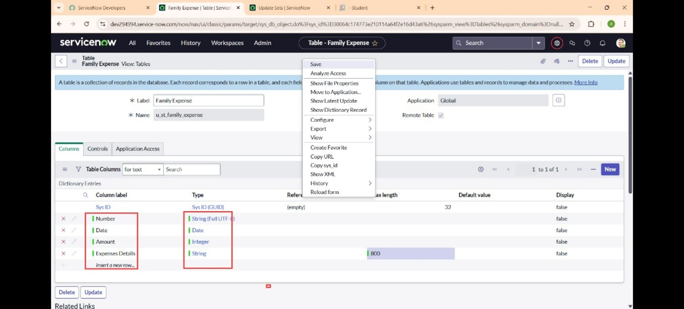

1. Move to the header, right click there >> click on Save.

**Activity 3 : Making Number Field an Auto-Number**

1. Double click on the Number Field/Column.
2. Go down and double click on Advanced view
3. In Default Value:

Use dynamic default : check the box

Dynamic default value : Get Next Padded Number

1. Click on Update.

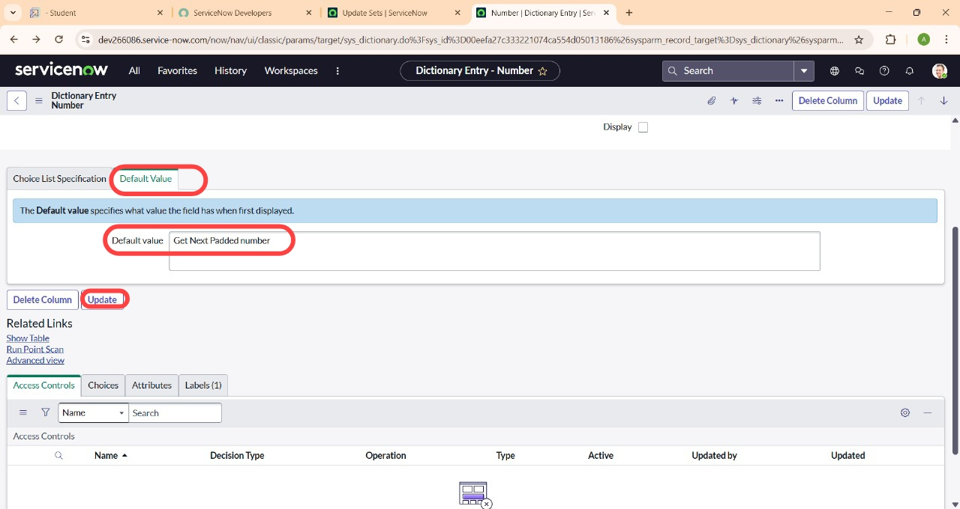

1. Go to All >> In the filter search for Number Maintenance >> select Number Maintenance.
2. Click on New
3. Fill out the details below :

* Table : Family Expenses
* Prefix : MFE

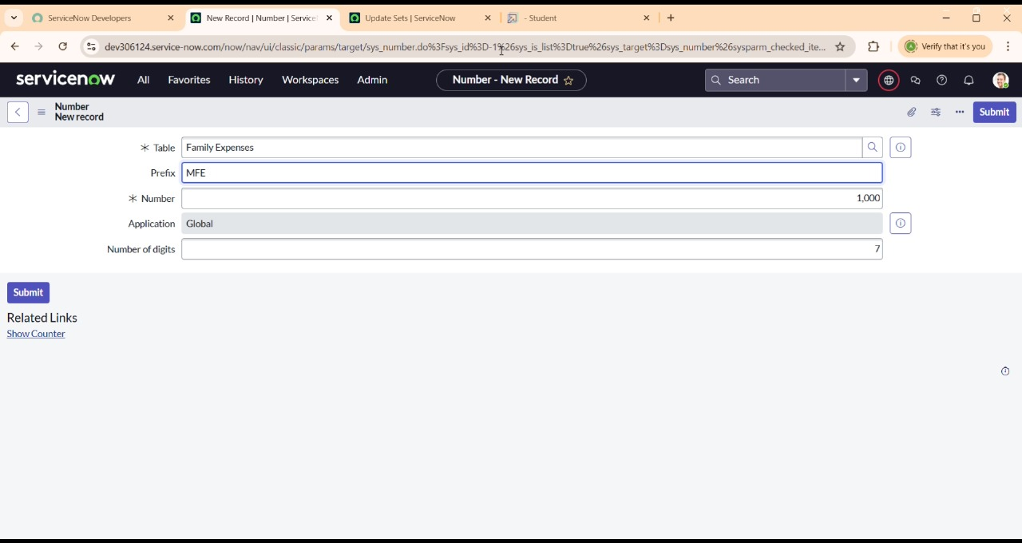

1. Click on Submit.

**Activity 4 : Configure the Form**

1. Go to All >> In the filter search for Family Expenses >> Open Family Expenses
2. Click on New
3. Go to the Header and right click there>> click on Configure >> Select Form Design
4. Customize the form or use drag-and-drop features according to your requirements

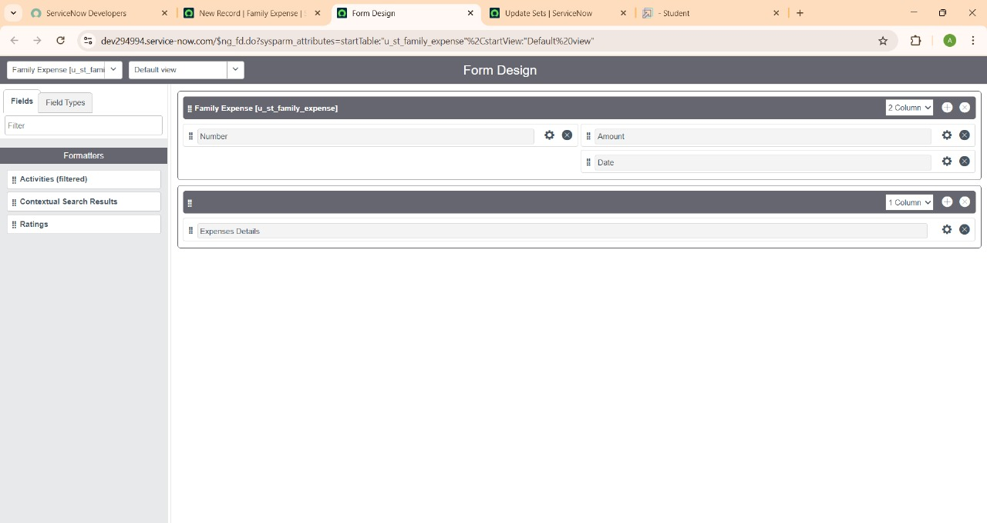

1. Set the Number field to Read-Only by clicking the gear icon and selecting the Read-Only option.
2. Make Date, Amount Mandatory Field by clicking on the gear icon and checking Mandatory
3. Click on Save.

**Milestone 5 : Creation of table (Daily expenses )**

**Activity 1 : Creation of Daily Expenses Table**

1. Go to All > In the filter search for Tables > click on New.
2. Fill the Details as specified :

* Label : Daily Expenses
* Name : Auto-Populated
* Add Module to menu : Family Expenditure



1. Move to the Header and right click there>> click on Save.

**Activity 2 : Creation of Columns(Fields)**

1. Near Columns Double click near insert a new row.

Give the details as:

* Column label : Number
* Type : String

1. Double-click again to insert a new row.

Give the details as:

* Column label : Date
* Type : Date

1. Double-click again to insert a new row.

Give the details as:

* Column label : Expense
* Type : Integer

1. Double-click again to insert a new row.

Give the details as:

* Column label : Family Member Name
* Type : Reference
* Max length : 800

1. Double-click again to insert a new row.

Give the details as:

* Column label : Comments
* Type : String
* Max length : 800



1. Go to the Header and right click there>> click on Save.

**Activity 3 : Making Number Field an Auto-Number**

1. Double click on the Number Field/Column.
2. Go down and double click on Advanced view
3. In Default Value:

* Use dynamic default : check the box
* Dynamic default value : Get Next Padded Number

1. Click on Update.



1. Go to All >> In the filter search for Number Maintenance >> select Number Maintenance
2. Click on New.
3. Fill out the details below :

* Table : Family Expenses
* Prefix : MFE



1. Click on Submit

**Activity 4 : Configure the Form**

1. Go to All >> In the filter search for Daily Expenses >> Open Daily Expenses
2. Click on New
3. Go to the Header and right click there>> click on Configure >> Select Form Design
4. Customize the form or use drag-and-drop features according to your requirements



1. Set the Number field to Read-Only by clicking the gear icon and selecting the Read-Only option.
2. Make Date, Family Member Name Mandatory Field by clicking on the gear icon and checking Mandatory
3. Click on Save.

**Milestone 6 : Creation of relationship**

**Activity 1 : Creation of Relationship between Family Expenses and Daily Expenses tables**

1. Go to All >> In the filter search for Relationships >> Open Relationships
2. Click on New.
3. Fill out the details:

* Name : Daily Expenses
* Applies to table : Select Family Expenses
* Daily Expenses : Select Daily Expenses

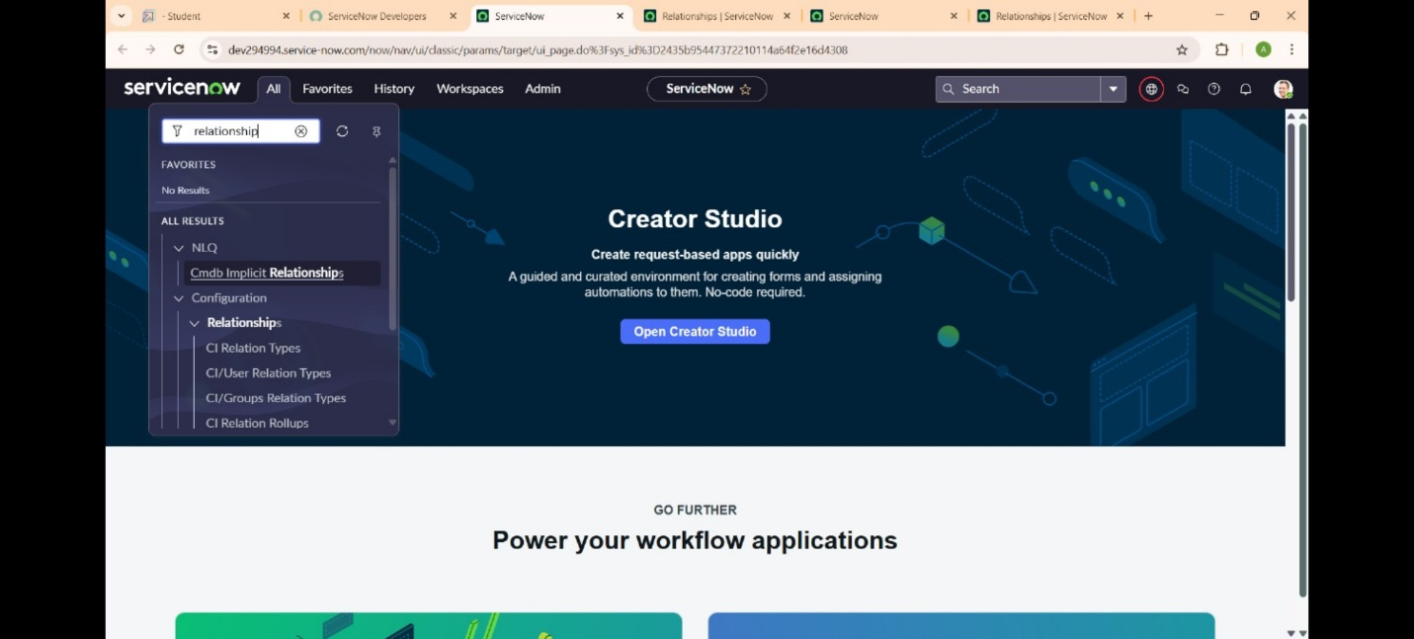

1. Click Save.

**Milestone 7 : Configuring Related List on Family Expenses**

1. Go to All >> In the filter search for “Family Expenses “ >> Open Family Expenses
2. Click on New
3. Move to the Header and right click there>> click on Configure >> Select Related Lists
4. Insert daily expenses into the selected area.

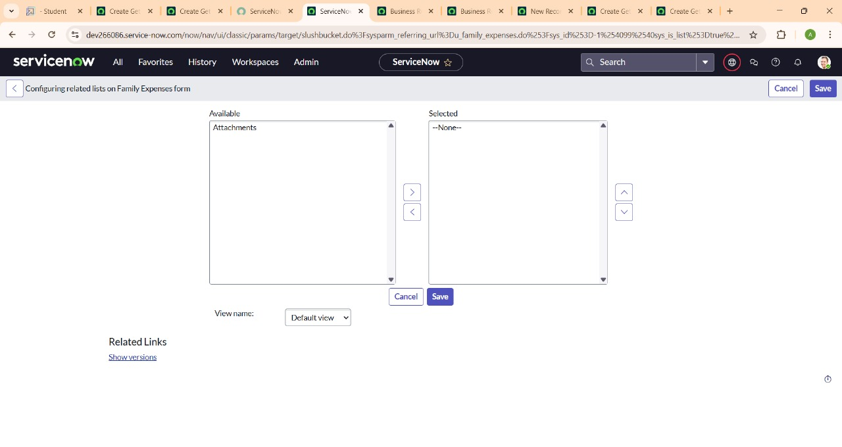

**Milestone 8 : Creation of Business rules**

1. Go to All >> In the filter search for Business Rules.
2. Under System Definition Select Business Rules then click on New.

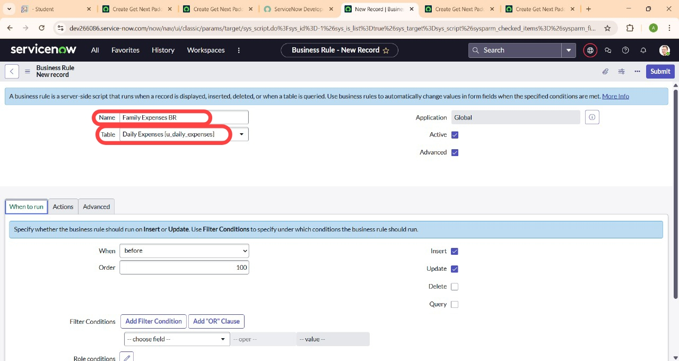

1. Enter the Details:

* Name : Family Expenses BR
* Table : Select Daily Expenses

Check Advanced

1. In when to run, Check Insert and Update

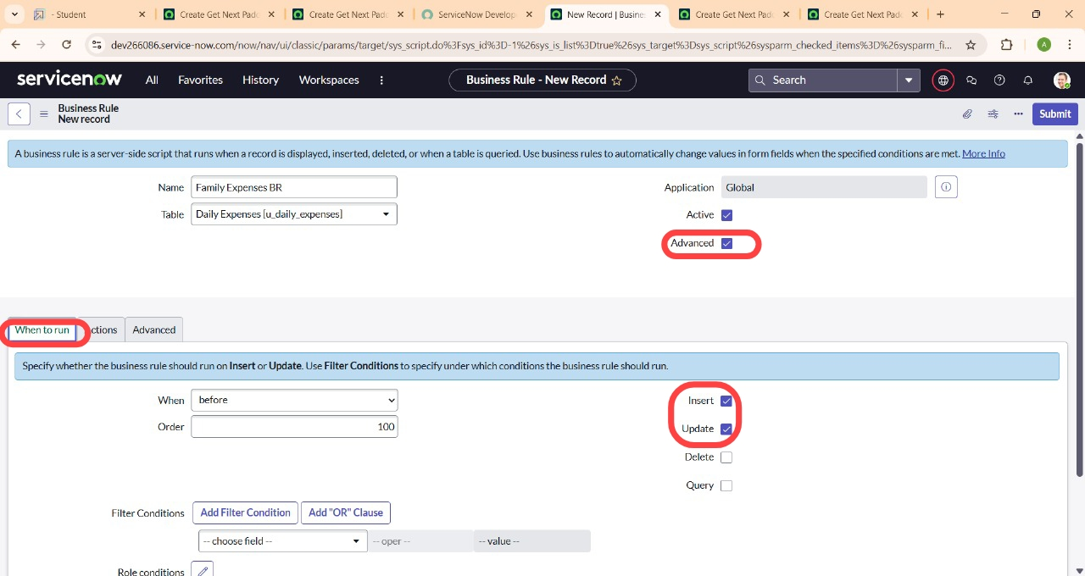

1. In Advance(we write the code): Write the below code >>

(function executeRule(current, previous /*null when async*/) {

Var FamilyExpenses = new GlideRecord(‘u_family_expenses’);

FamilyExpenses.addQuery(‘u_date’,current.u_date);

FamilyExpenses.query();

If(FamilyExpenses.next())

{

FamilyExpenses.u_amount += current.u_expense;

FamilyExpenses.u_expense_details += “>”+current.u_comments+”:”+”Rs.”+current.u_expense+”/-“;

FamilyExpenses.update();

}

Else

{

Var NewFamilyExpenses.insert = new GlideRecord(‘u_family_expenses’);

NewFamilyExpenses.u_date = current.u_date;

NewFamilyExpenses.u_amount = current.u_expense;

NewFamilyExpenses.u_expense_details += “>”+current.u_comments+”:”+”Rs.”+current.u_expense+”/-“;

NewFamilyExpenses.insert();

}

})(current, previous);

1. Go to the Header and right click there>> click on Save.

**Milestone 9 : Configure the Relationship**

1. Go to All >> In the filter search for Relationships >> Open Relationships.
2. In that, open Daily Expenses Relationship.
3. For Applies to table : Select Family Expenses.
4. In Query with : write the below Query.

(function refineQuery(current, parent) {

// Add your code here, such as current.addQuery(field, value);

Current.addQuery(‘u_date’,parent.u_date);

Current.query();

})(current, parent);

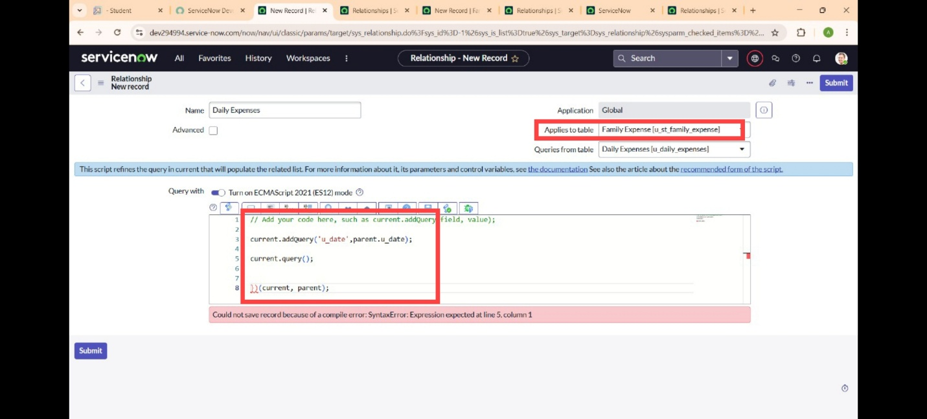

1. Click on Update.

**Conclusion :**

The “Calculating Family Expenses using Service Now” project successfully demonstrates how digital platforms like Service Now can be leveraged to streamline personal finance management at the family level. By integrating key functionalities such as expense categorization, budget setting, real-time tracking, and detailed reporting, the system offers a centralized and user-friendly solution for monitoring and controlling household expenditures. The inclusion of IOT open hardware platforms further enhances the system’s capabilities by enabling automated data collection from smart devices, ensuring accurate and up-to-date expense tracking.

The implementation of appropriate data structures ensures efficient storage, retrieval, and manipulation of financial data, contributing to the system’s responsiveness and scalability. Ultimately, the project not only simplifies financial oversight but also fosters informed decision-making, financial discipline, and overall financial well-being for families. This innovative approach sets a foundation for future enhancements, including AI-driven insights and broader integrations, making it a valuable tool for modern households.